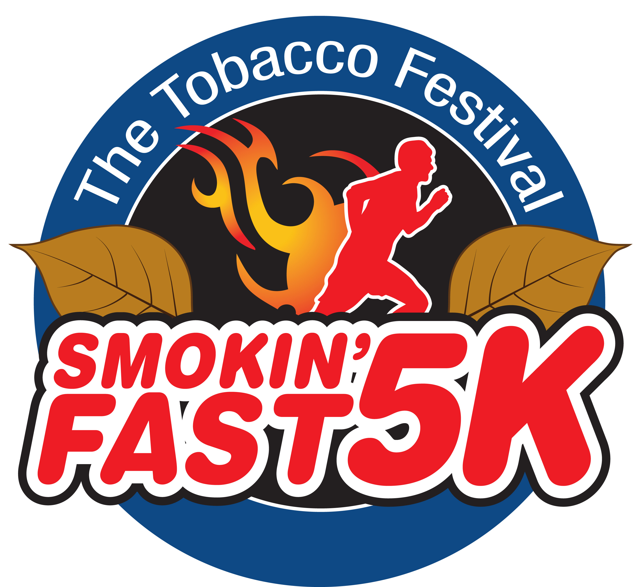

Back for another year!! During the 2014 South Carolina Tobacco Festival, The Greater Lake City Chamber of Commerce will be hosting a 5k Run/Walk.

When: Saturday, September 20st. Check-in and late registration will be from 7:00 to 8:00, the
run / walk will begin at 8:15, and awards / prizes will be at 9:30.
Where: The Greater Lake City Chamber of Commerce will be the host of the event. The 5K will start and finish at the Village Green on Henry St.
How Much: Entry is $25 for ages 10 and up. Ages 9 and under may participate for free if they stay with a registered adult for the entire course.
Prizes: Cash Prizes and gift certificates will be awarded to the Top 3 overall Male and Female Finishers. Each Participant will get a T-Shirt.

Please do not bypass this event because you do not run or jog! Walkers are welcome!

If you need more information, you can go to the Chamber or call 843-374-8611. Please help us by registering with the form below and by spreading the word about this event.
------------------------------------------------------------------------------------------------------------
S.C. Tobacco Festival Smokin’ Fast 5K Run / Walk Registration Form

Name: _______________________ Circle one: M / F On 9/20/14, I will be __ years old T-Shirt Size : S M L XL
Please make checks payable to The Greater Lake City Chamber of Commerce and either hand-deliver them to the Chamber or Wil Thomy or mail them to:
Release: In consideration of the acceptance of this entry, I hereby, for myself, my heirs, executors, administrators and assigns, release and discharge the sponsors and operators of the SC Tobacco Festival Smokin’ Fast 5K Run / Walk from any and all claims for damages suffered by me as the result of my participation in or traveling to or from the event, to be held on 9/20/2014.
The Greater Lake City Chamber of Commerce
Attn: Smokin’ Fast 5K
PO Box 669
Lake City, SC 29560

